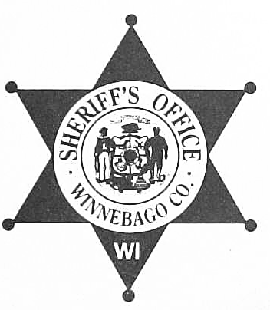
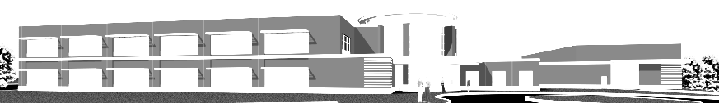

Sheriff
John F. Matz

Chief Deputy
Todd A. Christopherson

Winnebago County Sheriff

www.co.winnebago.wi.us

4311 JACKSON STREET

OSHKOSH, WISCONSIN 54901
(920) 236-7300 (920) 727-2888
JAIL (920) 236-7380
ADMINISTRATION FAX (920) 236-7333
RECORDS FAX (920) 236-7302

AUTHORIZATION FOR RELEASE OF INFORMATION
AND RELEASE FROM LIABILITY

TO: Any Person being shown a copy of this Authorization

I am an applicant for a position with the Winnebago County Sheriff’s Office. The Winnebago County Sheriff’s Office needs to thoroughly investigate my background to evaluate my qualifications to hold the position for which I applied. It is in the public’s interest that any relevant information concerning my personal and employment history is disclosed to the Winnebago County Sheriff’s Office.

I hereby authorize any employee of the Winnebago County Sheriff’s Office to obtain any and all information, written or oral, typed or in the form of hard copy record, that you may have concerning me; including any criminal or driving record that I may have, my past and present employment, all educational records, records and/or oral statements relating to my reputation, my conduct and my financial and credit status.

The intent of this authorization is to provide full and free access to the background and history of my personal life, for the specific purpose of pursuing a background investigation that may provide pertinent data for the Winnebago County Sheriff’s Office to consider in determining my suitability for employment. It is my specific intent to provide access to personnel information however personal or confidential it may appear to be. I consent to your release of:

- Any and all public and private information that you may have concerning me
- My work financial status
- My criminal history record, including any arrest records and information contained in investigatory files
- My efficiency ratings
- Complaints or grievances filed by or against me
- The records or recollections of attorneys at law or other counsel, whether representing me or another person in any case, either criminal or civil, in which I presently have, or have had an interest
- Attendance records
- Any internal affairs investigations and discipline, including any files which are deemed to be confidential and/or sealed

I hereby authorized the Social Security Administration to release information or records from my file as to names and addresses of all employers shown on my detailed earnings history.

I hereby release and hold harmless any individual, institution or agency, including its officers, employees or other related personnel, both individually and collectively, from any and all liability for damages or whatever kind, which may at any time result to me, my heirs, my family or associates, or any other person claiming on my behalf because of compliance with this

authorization and request to release information or any attempt to comply with it, whether that released information be oral or written in nature. I direct you to release such information upon
request of the representative of the Winnebago County Sheriff’s Office, regardless of any agreement I may have made with you previously to the contrary. The law enforcement organization requesting the information pursuant to this release will discontinue processing my application if you refuse to disclose the information requested.

For and in consideration of the Winnebago County Sheriff’s Office acceptance and processing of my application for employment, I agree to hold the Winnebago County Sheriff’s Office and its agents and employees harmless from any and all claims and liability associated with my application for employment or in any way connected with the decision whether or not to offer me a position with the Winnebago County Sheriff’s Office.

I hereby waive any rights to inspect, review or otherwise obtain the contents of the background investigation conducted by the authorized agent of the Winnebago County Sheriff’s Office, including any and all rights I may have under Chapter 103 and Chapter 19, or any other sections of the Wisconsin Statutes. I further waive any other rights I may have to inspect and view, or have produced to me the contents of this background investigation as provided for in any other applicable document or statute, including but not limited to, any labor contracts or employment agreements or any federal statutory or administrative regulations.

A photocopy reproduction of this authorization, when supplied by an employee of the Winnebago County Sheriff’s Office, shall be for all intents and purposes as valid as the original. You may retain the photocopy for your files.

Printed Name:

Date of Birth:

Social Security:

Home Phone:

Home Address:

City: State: Zip Code:

Signature:__________________________________________________________________

*************************************************

The above named individual personally came before me and signed this Authorization for Release of Information and Release from Liability after having an opportunity to review the same.

Signature of Witness:______________________________________ Date:_____________

Printed Name of Witness:

04/08/11 sjs

