*Please contact us...*

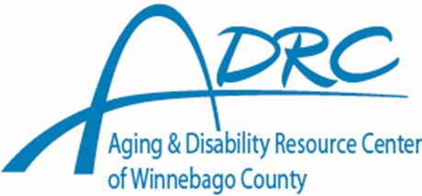

220 Washington Ave Oshkosh, WI 54901

211 N. Commercial St.

Neenah, WI 54956

Call Toll Free

877-886-2372

[adrc@co.winnebago.wi.us](mailto:adrc@co.winnebago.wi.us)

220 Washington Ave

PO Box 2187

Oshkosh ,WI 54903-2187

[www.co.winnebago.wi.us/ADRC](http://www.co.winnebago.wi.us/ADRC) No Appointment Necessary Hours of Operation:

Monday - Friday

8:00 a.m. - 4:30 p.m.

additional hours available by appointment



**Call Toll Free**

**877-886-2372**

[**adrc@co.winnebago.wi.us**](mailto:adrc@co.winnebago.wi.us)[**www.co.winnebago.wi.us/adrc**](http://www.co.winnebago.wi.us/adrc)







# What help is available from the ADRC?



**What is an ADRC?**

The ADRC is a no-cost, single point of contact for information and assistance. It can help you, or a loved one, sort out available options so you can make an

* Information and Assistance
* Long Term Care Options Counseling
* Access to Long Term Care Programs

FAQ’s

* Benefits Counseling
* Prevention Services
* Adult Protective Services
  + Powers of Attorney
  + Guardianship



* + Involuntary Placement

*How to find us*

# 220 Washington Ave.

**Oshkosh, WI 54901**

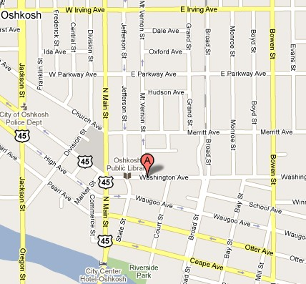

informed decision about how to proceed and be in control of choices affecting your independence. An ADRC is a visible and trusted place to turn to when you have questions about long-term care in Winne- bago County.

# Who does the ADRC serve?

* Persons over 60 years of age.
* Adults 18 years and older with physi- cal and/or developmental disabilities.
* Family, Caregivers, and others who need information about Long-Term Care programs and services.

# Do you have information regarding resources?

The ADRC has an up-to-date resource

directory listing various agencies throughout

Winnebago County.

# What other information and assistance is available?

The ADRC can provide information and assis- tance in applying for public assistance pro- grams such as:

* Family Care
* IRIS (Include, Respect, I Self-Direct)
* Other Public Benefits

**211 N. Commercial St. Neenah, WI 54956**

